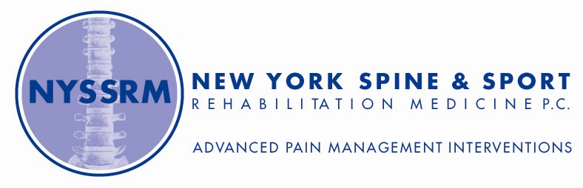
Referral Sheet

□ Sireen Gopal, MD Physical Medicine, Rehabilitation, Pain Medicine
□ Bryan Elzholz MD Anesthesiology, Pain Management
□ Direct Physical Therapy Referral (see over)

Patient Name: _____________________________Diagnosis: _______________________________

□ Consult - Evaluation & Non-Surgical Management:
□ Diagnostic testing as indicated (Xrays, MRIs, Laboratory testing)
□ Supervised & Patient Specific Physical Therapy □ Trigger point injection □ Joint injection □ Tendon sheath
□ Sacroiliac joint injection (fluoroscopic guidance) □ Hip joint injection fluoro-guided □ Electrodiagnostic testing (NCS/EMG)

□ Consult - Interventional Pain Medicine:
Treatment of Radicular Cervical/ Lumbar pain □ Epidural/Transforaminal Nerve Root Injections
Treatment of Axial Cervical/Lumbar Spine pain □ Facet joint injection □ Median Branch Block
Treatment of Chronic Axial Spine pain □ Radiofrequency waves to ablate pain nerve endings
Treatment of RSD/ Complex Regional Pain Syndrome □ Stellate / Lumbar Sympathetic blocks
Treatment of Headaches □ Upper Cervical Facet Medial Branch Block
Treatment of Atypical Facial pain/ Trigeminal Neuralgia □Trigeminal Nerve Block
Treatment of Chronic Pelvic pain □ Hypogastric/ Pudendal Block
Treatment of Chronic Abdominal pain □Splanchnic/ Celiac plexus Block

□ Advanced Percutaneous Procedures:
□ Neuro-modulation & Spinal Cord Stimulation Program □ Kyphoplasty
□ Discography – Study of disc as source of pain □ VIA Disc -injection of viable autograft

□ Adult Regenerative Medicine Consult:
□ Plasma Rich Platelet (PRP) □ Adult Stem Cell (Autograft -Bone Marrow, Fat -Lipogems) for tendons, joint, spine, cartilage, meniscus, labrum, muscle, hair, skin & sexual health
□ Functional/Integrative Medicine Consult:
□ Detailed Health Evaluation for toxins, systemic inflammation, gut health, hormones, psychosocial factors and others to address fundamental root causes for chronic symptoms and illnesses, using science based whole systems approach/principles of functional/integrative medicine
________________________________________________________________________________________
PHYSICIAN NAME SIGNATURE DATE

If you are a Doctor or Doctors office can use the new patient referral hotline at 212.661.4452

□1250 Waters Place, Suite 710, Bronx, NY 10461 PHONE: 718.794.0600 FAX: 718.794.9899
□ 984 North Broadway, Suite 510, Yonkers, NY 10701 PHONE: 914.984.5949 FAX: 718.794.9899
□ 800 2nd Avenue, 9th Floor, Suite A, New York, NY 10017 PHONE: 212.661.4454 FAX: 212.991.9901

www.nyspineandsport.com www.vitalitymedny.com

Physical Therapy Prescription
Chief Physical Therapist: Manoj Thomas, MPT

□1250 Waters Place, Suite 710, Bronx, NY 10461 PHONE: 718.794.0600. FAX: 718.794.9899
□ 984 North Broadway, Suite 510, Yonkers, NY 10701 PHONE: 914.984.5949 FAX: 718.794.9899
□ 800 2nd Avenue, 9th Floor, Suite A, New York, NY 10017 PHONE: 212.661.4454 FAX: 212.991.9901

Name: ___________________________________________________________________________________________

Diagnosis: _________________________________________________________________________________________

Frequency: □ 2 visits/week □ 3 visits/week Duration ____weeks

Precautions: ____________________________________________

□ NWB □ WBAT □ FWB

Treatment:

□ Evaluate and treat as indicated
□ Therapeutic exercises
□ Dynamic Spine Stabilization techniques:
□ Soft tissue Flexibility □Joint mobility □ Stabilization program □ Flexion or □ Extension Bias
□ Mckenzie program □ Abdominal program □Gym program
□ Isometrics □ Isotonics □ Isokinetics
□ Joint Mobilization □ Myofascial release □ AROM □ AAROM □ PROM exercises
□ Posture, Body mechanics □ Gait training □ Balance Training
□ Traction □ Modalities as indicated
□ Stretching, Strengthening exercises □ Ultrasound □ Laser therapy
□ Plyometrics □ Electrical Stim
□ Phonophoresis □ Iontophoresis □ TENS trial □ Heat, Cold
□ Neuromuscular re-education techniques □ Proprioceptive exercises □ Fall Prevention
□Other______________________________________________________________________________________________________ ________________________________________________________________________________________________________________________________________________________________________________________________________________________

All patients will be educated in a continuing and progressive home exercise program

__________________________________________________________________________________________________
PHYSICIAN NAME SIGNATURE DATE

www.nyspineandsport.com www.vitalitymedny.com

